How to Configure Keycloak to Setup SAML Single Sign On

Login as Admin/Admin
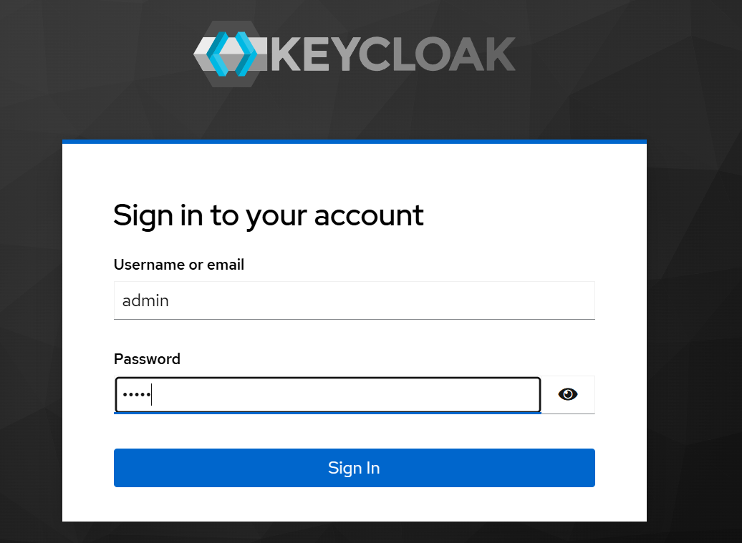

Create a Security Realm

Click Mange realms and then Create realm:
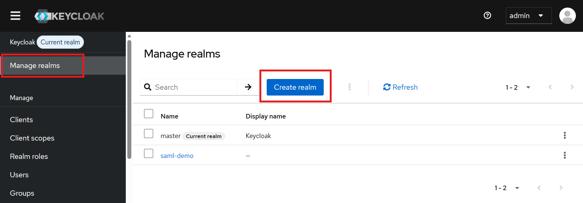
Provide a realm name then click Create:
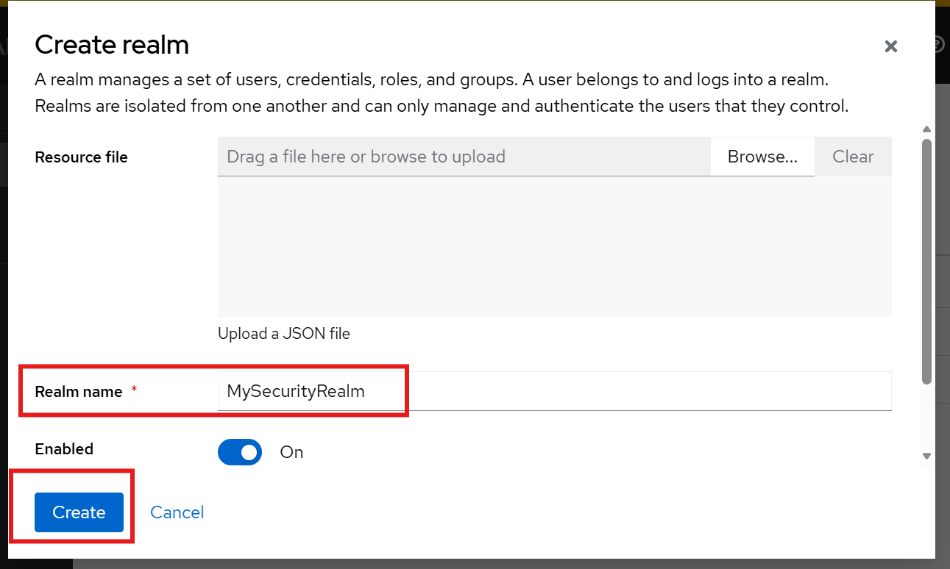

Explore realm SAML metadata by clicking Realm settings, then click SAML 2.0 Identity Provider Metadata. Such metadata contains important information for applications (SP) to communicate with Keycloak during authentication. It should be include in the security configuration of the Spring applications.
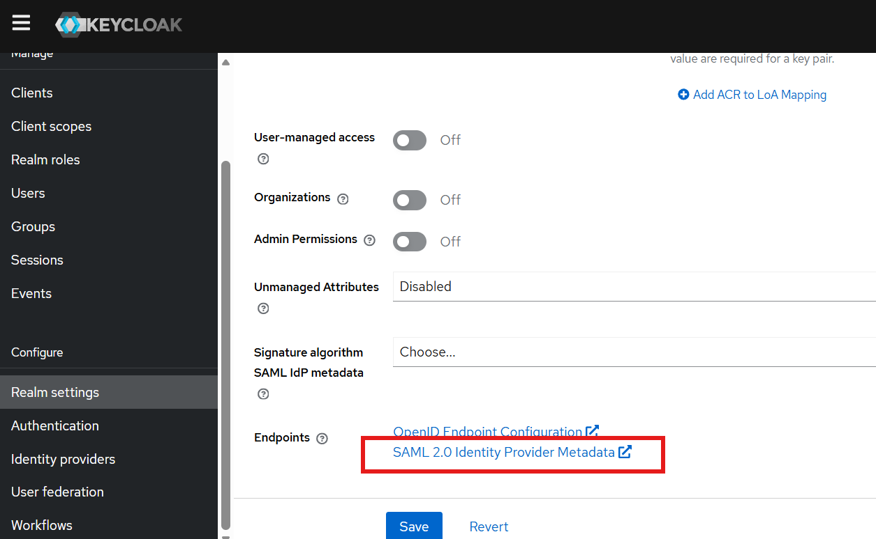

The IDP metadata should look like:
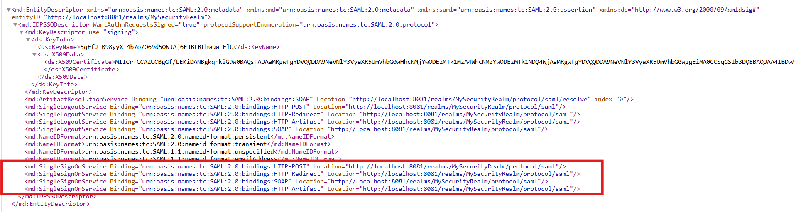

Create Clients in the Security Realm
Make sure the current realm is your newly created realm. A client in Keycloak describes a Service Provider, which should match the Spring Boot application.

Create the 1st Client:
Click Clients then click Create client:
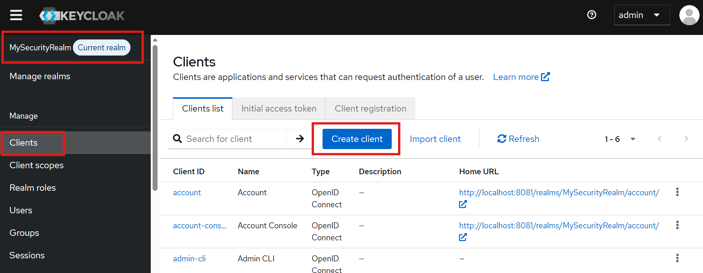

Choose Client type: SAML, enter Client ID: SpringBoot_SAML_App1, then click Next:
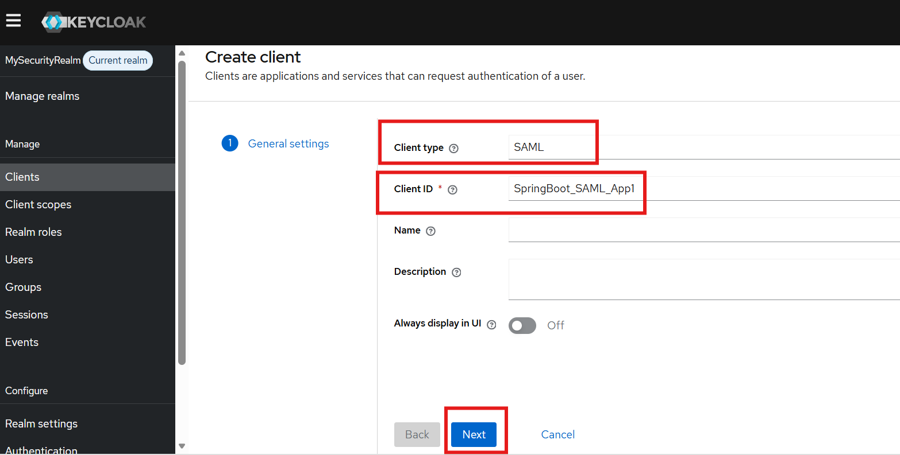

Enter the URLs about the Spring Boot application and click Save. The Master SAML Processing URL will be used for every binding to both the SP's Assertion Consumer and Single Logout Services. “/login/saml2/sso/keycloak” is a default URL that tells Spring Security to handle SAML Assertion Consumption.

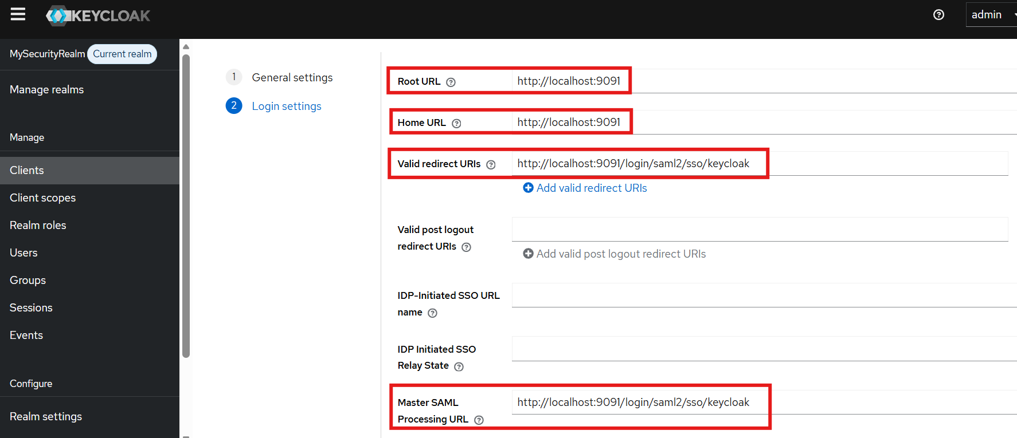

Temporally disable Client signature required. Signature is about public key/private key (TODO)
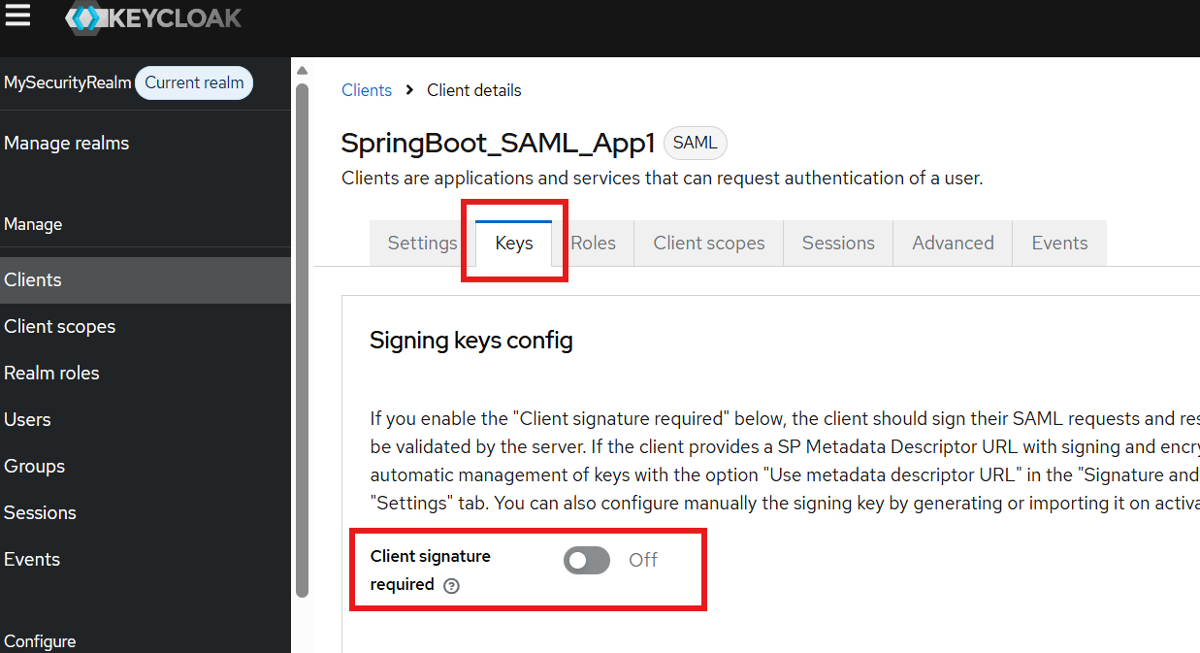

Create a 2nd Client:
Click Clients then click Create client:


Choose Client type: SAML, enter Client ID: SpringBoot_SAML_App2, then click Next:
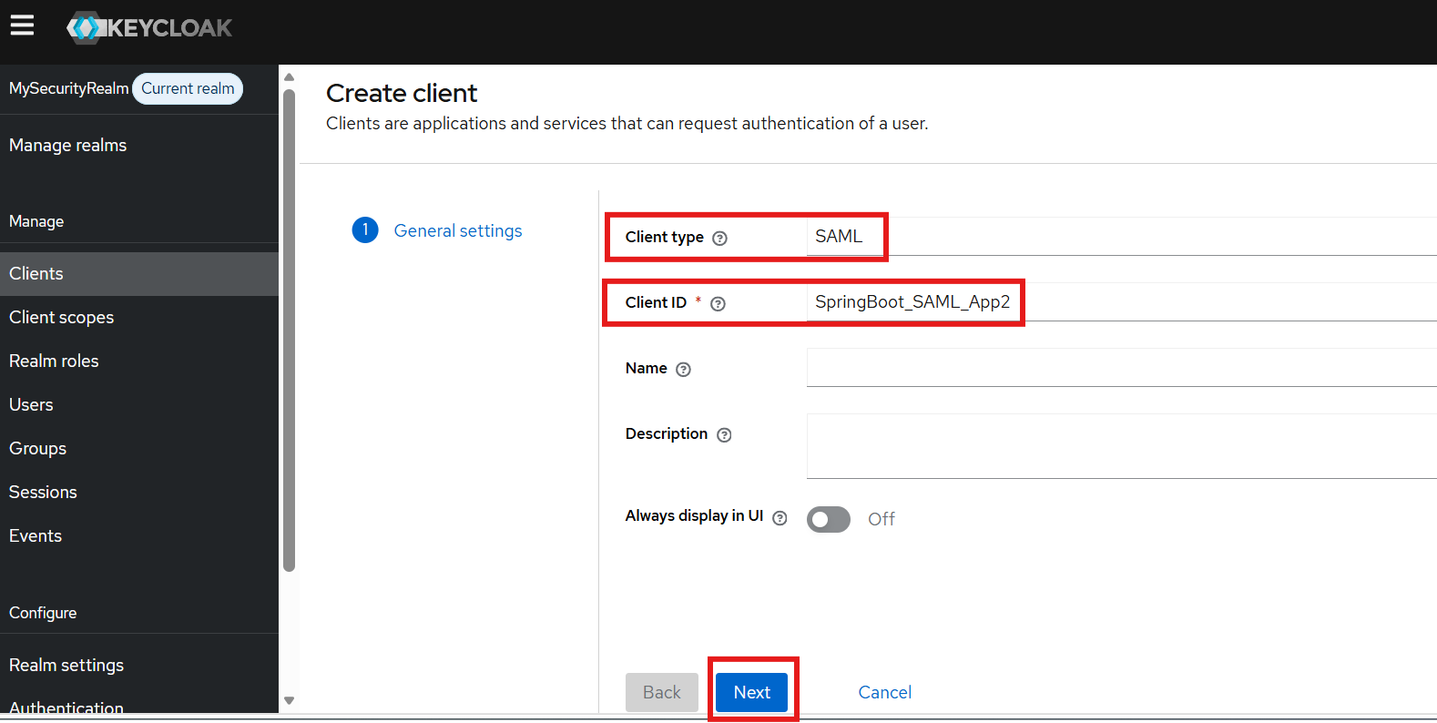

Enter the URLs about the Spring Boot application and click Save. The Master SAML Processing URL will be used for every binding to both the SP's Assertion Consumer and Single Logout Services. “/login/saml2/sso/keycloak” is a default URL that tells Spring Security to handle SAML Assertion Consumption.

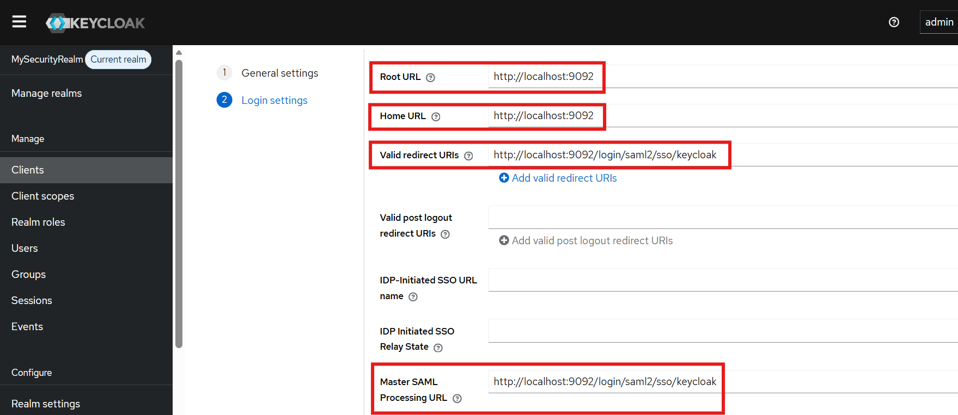

Temporally disable Client signature required. Signature is about public key/private key (TODO)
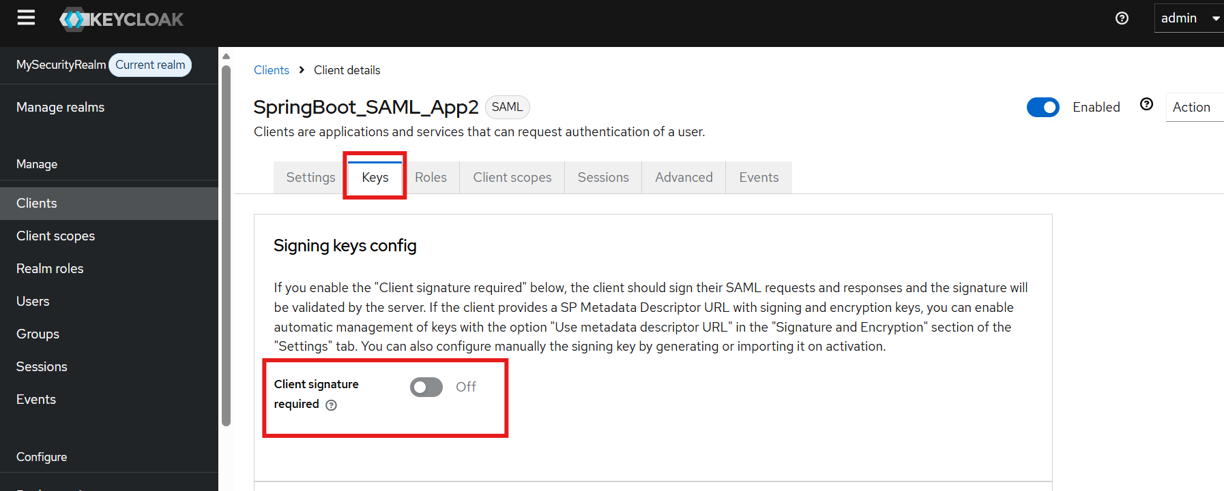

Create User in the Security Realm
A user in a Security Realm can potentially single sign on all Service Providers (Spring applications) configured under the Security Realm.
Click Users link and then click Create new user:
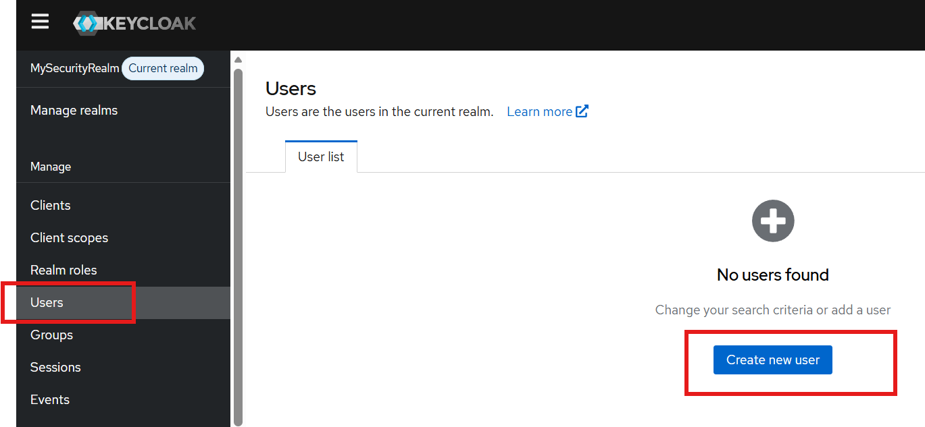

Enter Username and other information then click Create:
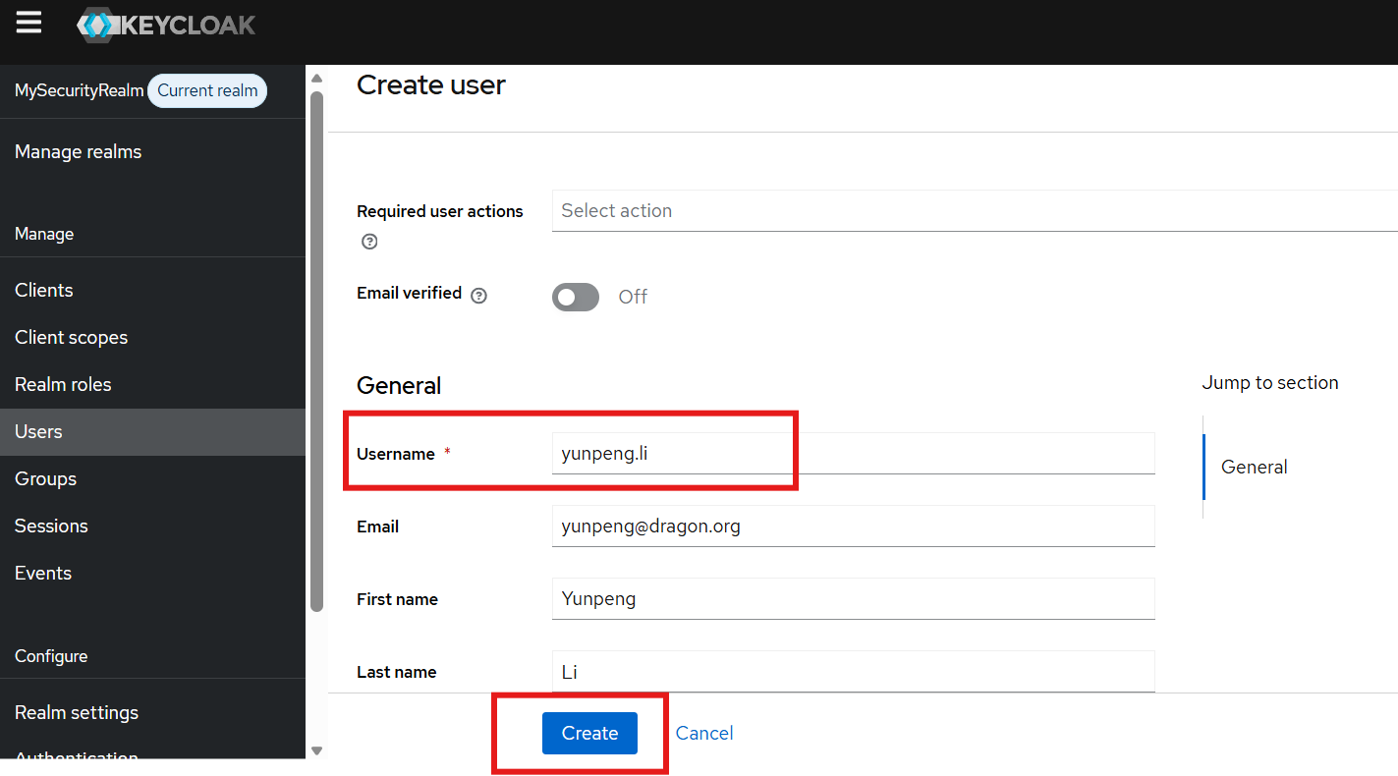
Click the Credential tab, then in the popup form, enter the password and choose the Temporary selection as Off (It won’t ask user to change password when first login), then click Save:
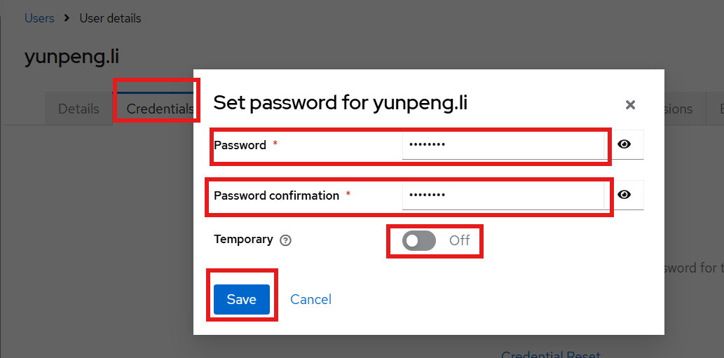

Demonstrate Single Sign On for two Spring Boot Applications

Start SpringBoot_SAML_App1, then access http://localhost:9091 in a browser. It will redirect to a Keycloak login screen:
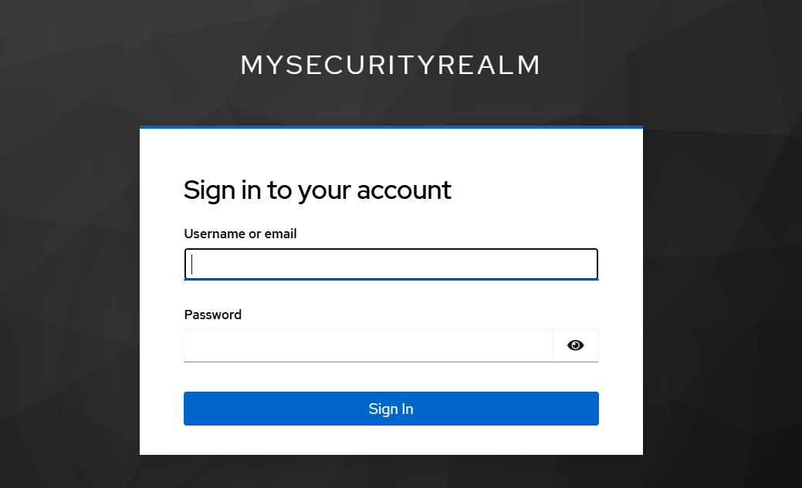
Start SpringBoot_SAML_App2, then access http://localhost:9092 in a browser. It will redirect to a Keycloak login screen:


In the login screen for SpringBoot_SAML_App1, enter username (yunpeng.li) and password (password) and click Sign In. It will redirect to the home page of SpringBoot_SAML_App1.
Retype the URL http://localhost:9092 for SpringBoot_SAML_App2 in the browser. It will not show Keycloak login page but show the home page of SpringBoot_SAML_App2.

Login as admin in Keycloak and access Users under the Security Realm. It shows the user has both client sessions:
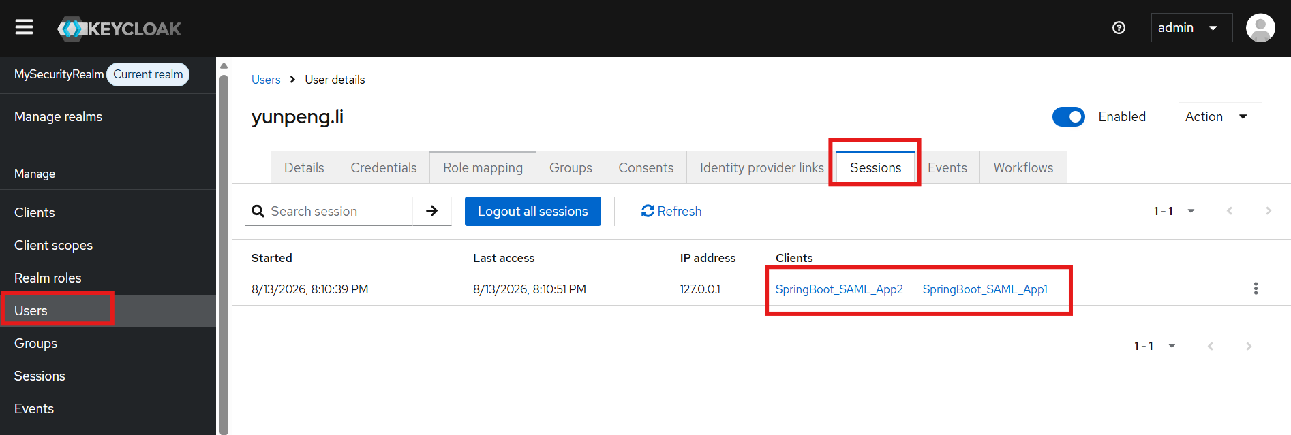

You can sign out the user from both client sessions:
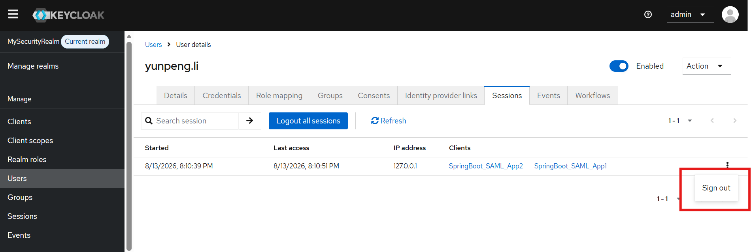

After user is signed out, accessing SpringBoot_SAML_App1 or SpringBoot_SAML_App2 requires login again.

